**USMAN IRSHAD**

* Address : House No A75
* Email : 03268953672

# ➢ contact : irshadusman267@gmail.com

# CAREAR OBJECT

Too fill the change my position all me to utilize my creativity expertise and experience to play a part in moving the organized forward long term basic get an environment

# Academic Qualification

* **D.A.E:(Software Engineering ) ( In Progress )**

**From metro star gate**

* **INTERMEDIA: (Science) ( In Progress )**

**From metro star gate**

* **Matriculation :(science)**

**FROM BOARD OF TECHNICAL EDUCATION KARACHI**

**EMPLOY HISTORY:**

02 YEAR EXPERIENCE OF RADIOGRAPHAR IN ATIA HOSPITAL 01 YEAR EXPERIENCE OF COUNTER SALE IN MADICAL STORE

#   PERSONAL INFORMATION

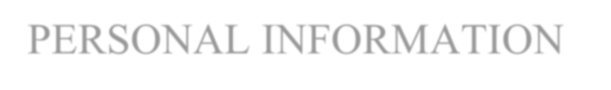

FATHER NAME IRSHAD ALI

CNIC # 42501-0487545-9

D .O. B 05-10-2006

RELIGION ISLAM

NATIONLITY PAKISTAN

MARTIAL SINGLE

* **REFRENCE**

REFRENCE WILL BE FUNISHED UPON REQUEST

## 